OXFORD FLYING CLUB

MEETING MINUTES
Regular Meeting, March 21, 2006

Attendees: Aulet, Carmona, Crabtree, DaSilva, Fournier, Green, Kett, Nalband, Noffke, Palmatier, Piwowarski, Proulx, Sabot, Schmecker, Smith, Vecchiarelli, Willenbring, Wilson
- 16 Regular Members and 1 Student Member (Quorum)
- 1 Associate Member

General: Meeting called to order at 7:03 PM. February minutes approved.

Treasurer Report: Brian Willenbring presented the treasurer’s report:
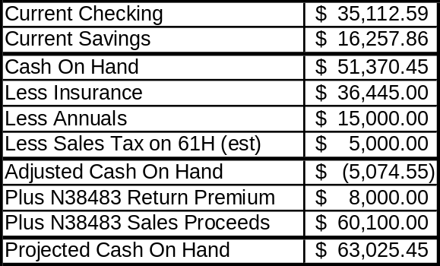
- Dues for the Month of March will be $205.
- Report accepted unanimously.

Maintenance Report: Brian Proulx presented the maintenance report:
- N38483:
  - Needs a new visor—about $150.
- N4384F:
  - Appears to have a precession problem with the directional gyroscope. Will address this at the annual in May.
  - Compass issues: Requires new gasket and compass card holder. Club approved a motion to purchase a vertical compass card.
- N8261H:
  - Will be at SAS for annual April 4.
  - Airworthiness Directive regarding vacuum pump will have to be addressed.
  - Electric Trim flagged for inspection
  - Flat spot on right tire.
  - DME switch may have a ground problem.
- N33659:
  - Needs new landing light assembly.
  - Primer issue – will examine O-ring.
- Reminder: Garmin training is available through the Flying 20s club 8 April, 9:00AM-12:00PM at Danbury. Sign-up sheet was passed around at the February meeting.
- Scott Crabtree requested Brian P verify the Garmin’s stormscope works.

Safety:
- Jeff Parkin presented “Operating in Class B – How not to play the fool.” Many thanks, Jeff. Great presentation!
- Max Aulet suggested the club participate in the FAA Safety Fest in Hartford on 13 May; set up booth, advertise and recruit for the club. Membership gave an enthusiastic “Do it!” Will need volunteers to assist Max.

Membership: Have four prospective new members:
- Angela Finelli
- Ken Cohen
- Craig Nichols
- Joe D’Uva

Old Business:
- Richard Wilson reported on the sale of N38483. Buyer has offered $60,100. Arrangements underway for inspection and turnover of aircraft on 26 and 27 March. Watch email for more details.
- Brian Willenbring raised topic of 659 lease agreement. After some discussion, club agreed to table the discussion until the April meeting. Will continue $85 per hour going to owner until addressed at next meeting.
- Subject of taxes will be raised again in April.

New Business:
- GPS updates: Club needs to think about regular updates. For the KL89B, it will cost $380 per year. Requires a PC interface for a cost of $1000 to $2500 depending on who we have installing the interface (OFT vs VIP). Club approved motion to purchase GPS database update package.
- Club approved two requests for extended reservations:
  - Steve Fournier (84F: 30 June to 14 July)
  - Geoff Green (61H: 14 to 22 April) Note: There is an apparent maintenance conflict.
- Four By Laws amendments proposed in February were not discussed in March:
  - Amendment requiring a Private License to fly 61H, meaning a student pilot could not fly it, solo or otherwise.
  - Amend by-laws changing the member-to-plane ratio from 12:1 to 15:1.
  - Change to the bylaws to allow associate members who are also certified flight instructors to fly club aircraft in a non-instructional pilot-in-command capacity as long as they do so in the furtherance of club business.
  - Change the bylaws to make persons who rejoin the club pay the difference between the initial membership fee paid on previous entry and the initial membership fee in effect when rejoining.
- These amendments plus taxes will be on the agenda for April’s meeting.

Adjournment: 8:57 PM

Next Meeting: April 18, 2006, 7:00 PM, Main Terminal, OXC

Respectfully submitted,
/s/
Bruce Palmatier

